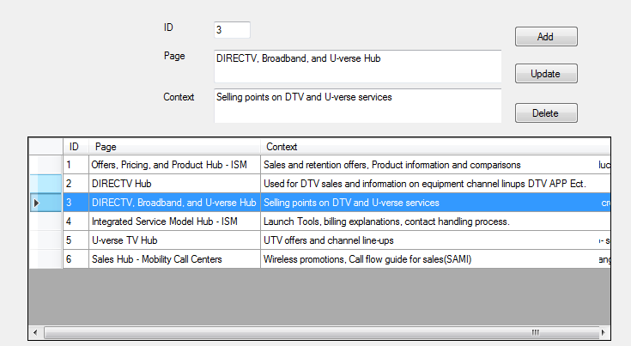

using System;

using System.Data;

using System.IO;

using System.Windows.Forms;

using System.Xml;

namespace HelpConfigurationStore

{

public partial class Form1 : Form

{

public string filepath = "ConfigurationStore.xml";

public Form1()

{

InitializeComponent();

}

private void LoadXML()

{

DataSet ds = new DataSet();

DataTable dt = new DataTable();

dt.Columns.Add("ID");

dt.Columns.Add("Page");

dt.Columns.Add("Context");

ds.Tables.Add(dt);

XmlDocument xdoc = new XmlDocument();

FileStream rfile = new FileStream(filepath, FileMode.Open);

xdoc.Load(rfile);

XmlNodeList list = xdoc.GetElementsByTagName("Item");

for (int i = 0; i < list.Count; i++)

{

XmlElement cl = (XmlElement)xdoc.GetElementsByTagName("Item")[i];

DataRow dr = ds.Tables[0].NewRow();

dr["ID"] = cl["ID"].InnerText;

dr["Page"] = cl["Page"].InnerText;

dr["Context"] = cl["Context"].InnerText;

ds.Tables[0].Rows.Add(dr);

}

rfile.Close();

dataGridView1.DataSource = ds.Tables[0];

dataGridView1.Columns[0].Width = 30;

dataGridView1.Columns[1].Width = 200;

dataGridView1.Columns[2].Width = 400;

}

#region ADD

private void button1_Click(object sender, EventArgs e)

{

int value;

if (!int.TryParse(textBox5.Text, out value))

{

MessageBox.Show("Type an Integer");

return;

}

XmlDocument xd = new XmlDocument();

FileStream lfile = new FileStream(filepath, FileMode.Open);

xd.Load(lfile);

XmlElement cl = xd.CreateElement("Item");

cl.SetAttribute("Name", "1");

XmlElement na0 = xd.CreateElement("ID");

XmlText natext0 = xd.CreateTextNode(textBox5.Text);

na0.AppendChild(natext0);

cl.AppendChild(na0);

XmlElement na1 = xd.CreateElement("Page");

XmlText natext1 = xd.CreateTextNode(textBox1.Text);

na1.AppendChild(natext1);

cl.AppendChild(na1);

XmlElement na2 = xd.CreateElement("Context");

XmlText natext2 = xd.CreateTextNode(textBox2.Text);

na2.AppendChild(natext2);

cl.AppendChild(na2);

xd.DocumentElement.AppendChild(cl);

lfile.Close();

xd.Save(filepath);

MessageBox.Show("Added");

textBox5.Text = "";

textBox1.Text = "";

textBox2.Text = "";

LoadXML();

}

#endregion

private void Form1_Load(object sender, EventArgs e)

{

if (**File.Exists("**ConfigurationStore.xml"))

{

LoadXML();

return;

}

**// SI EL ARCHIVO NO EXISTE CREELO**

**// \*\*\*\*\*\*\*\*\*\*\*\*\*\*\*\*\*\*\*\*\*\*\*\*\*\*\*\*\*\***

using (XmlWriter writer = XmlWriter.Create("ConfigurationStore.xml"))

{

writer.WriteStartElement("Root");

//writer.WriteElementString("id", "1");

//writer.WriteElementString("Page", "Mahesh Chand");

//writer.WriteElementString("URL", "Addison-Wesley");

//writer.WriteElementString("Notes", "64.95");

writer.WriteEndElement();

writer.Flush();

}

}

private void dataGridView1_CellClick(object sender, DataGridViewCellEventArgs e)

{

textBox5.Text = dataGridView1.Rows[e.RowIndex].Cells[0].Value.ToString();

textBox1.Text = dataGridView1.Rows[e.RowIndex].Cells[1].Value.ToString();

textBox2.Text = dataGridView1.Rows[e.RowIndex].Cells[2].Value.ToString();

lb55.Text = textBox5.Text;

}

private void button2_Click(object sender, EventArgs e)

{

if (textBox1.Text == "")

{

MessageBox.Show("Select a row");

return;

}

XmlDocument xdoc = new XmlDocument();

FileStream rfile = new FileStream(filepath, FileMode.Open);

xdoc.Load(rfile);

bool Deleted = false;

XmlNodeList list = xdoc.GetElementsByTagName("Item");

for (int i = 0; i < list.Count; i++)

{

XmlElement cl = (XmlElement)xdoc.GetElementsByTagName("Item")[i];

if (lb55.Text == cl["ID"].InnerText)

{

cl["Page"].InnerText = textBox1.Text;

cl["Context"].InnerText = textBox2.Text;

Deleted = true;

MessageBox.Show("Updated");

}

}

rfile.Close();

if (!Deleted)

{

MessageBox.Show("Item not found to be updated");

}

else

{

xdoc.Save(filepath);

LoadXML();

}

}

private void button3_Click(object sender, EventArgs e)

{

if (textBox1.Text =="")

{

MessageBox.Show("Select a row");

return;

}

XmlDocument xdoc = new XmlDocument();

FileStream rfile = new FileStream(filepath, FileMode.Open);

xdoc.Load(rfile);

bool Deleted = false;

XmlNodeList list = xdoc.GetElementsByTagName("Item");

for (int i = 0; i < list.Count; i++)

{

XmlElement cl = (XmlElement)xdoc.GetElementsByTagName("Item")[i];

if (lb55.Text == cl["ID"].InnerText)

{

xdoc.DocumentElement.RemoveChild(cl);

Deleted = true;

MessageBox.Show("Deleted");

}

}

rfile.Close();

if (!Deleted)

{

MessageBox.Show("Item not found to be deleted");

}

else

{

xdoc.Save(filepath);

LoadXML();

}

}

}

}